**JADAVPUR UNIVERSITY**

**Faculty of Engineering & Technology**

**Basic Electronics Laboratory**

Name: SOHAM CHOWDHURY

Class: CSE

Sec: A3

Roll No: 002110501149

Date of Experiment: 11/01/2021

Date of Submission: 06/04/21

Marks Obtained : ………………………

Signature of Examiner : ……………………………

Commence At: 11 AM Name of Teacher concerned: Nirmoy Modak

**EXPERIMENT NO: 01-A**

Title: Identification of Electronic Component and Meter Handling

Resistor:

Opposition to the flow of current is called resistance. The elements which have resistance are called resistors. Resistors are of two types :

1. Fixed value resistors like Carbon resistor, Wire wound resistance
2. Variable resistors like Potentiometer

Symbols: 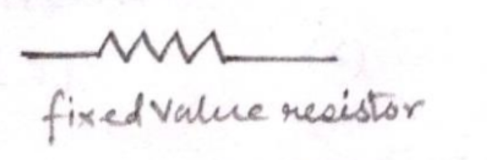 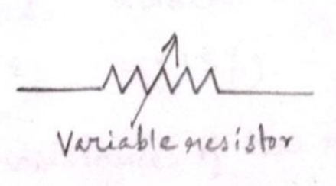

1. Carbon Resistor: Carbon resistors are fixed value resistors, made out of fine carbon particles mixed with a binder (like clay).
2. Identification of resistance value: The value of the resistance of a particular carbon resistor is identified from the color code on its body. 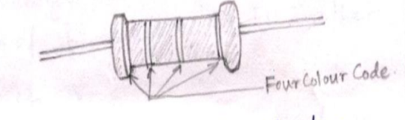
3. Codes on resistance:

|  |  |  |  |  |  |  |  |  |  |  |  |  |  |  |  |  |  |  |  |  |  |  |  |  |  |  |  |  |  |  |  |
| --- | --- | --- | --- | --- | --- | --- | --- | --- | --- | --- | --- | --- | --- | --- | --- | --- | --- | --- | --- | --- | --- | --- | --- | --- | --- | --- | --- | --- | --- | --- | --- |
| Colour Code:   |  |  | | --- | --- | | Colour | Number | | Black | 0 | | Brown | 1 | | Red | 2 | | Orange | 3 | | Yellow | 4 | | Green | 5 | | Blue | 6 | | Violet | 7 | | Grey | 8 | | White | 9 |   Tolerance level code:   |  |  | | --- | --- | | Color | Tolerance | | Golden | ±5% | | Silver | ±10% | | No color | ±20% | | For a carbon resistor having four-color band, the first two colors represent the abscissa, third color represents the exponent and fourth color represent the tolerance  Example: Let a color resistor have following color bands on its body:  Green Blue Red Golden  5 6 2 15%  Thus the corresponding resistance of resistor is 56×102±5%Ω  2021-03-31 (30).png |

1. Wire wound resistor:

|  |  |
| --- | --- |
| The resistors made by winding a thin metal alloy wire (nichrome) or similar wire onto an insulating ceramic former in the form of spiral helix. It is another type of fixed value resistor.  The resistance of a wire bound resistor is mentioned on its body. 2021-03-31 (31).png |  |

1. Potentiometer:

|  |  |
| --- | --- |
| A potentiometer is a three terminal resistor with a sliding or rotating contact that forms an adjustable voltage divider. If only two terminals are used, one end and wiper, it acts as a Variable resistor or rheostat.  Symbol: 2021-03-31 (32).png |  |

Identification of maximum resistance of potentiometers: The maximum value of resistance a particular potentiometer can achieve is mentioned on its body. For example, if a potentiometer has maximum resistance of 1kΩ, which means its resistance can be varied from 0 to maximum of 1kΩ

Capacitor:

A capacitor is a passive two-terminal electrical component used to store energy in electric field. Capacitors can be of different types, such as:

|  |  |
| --- | --- |
| 1. Electrolytic 2. Non electrolytic |  |
|  |  |

Symbol: 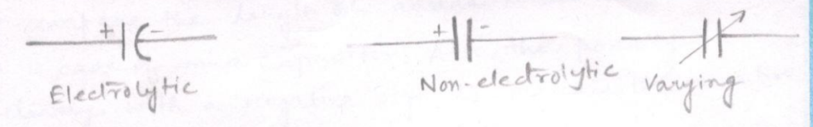

1. Mica Capacitor: It is a special type of capacitor made by coating of two sides of a small porcelain or ceramic disc with silver and is then slacked together two make the capacitor.
   * Determination of capacitance value: In case of this type of capacitor, a three digit code is printed onto their body which represents the capacitance value in picofarad (pF) units. The first two digits are the abscissa, third digit is exponent.

E.g.: If the code printed on the body of mica capacitor be 154, then,

The capacitance value = 15×104 pF

            = 15×10410-12 F

            = 15×10-8F

              = 0.15 µF

* Identification of Polarity: A very easy way to determine the polarity of such type of capacitors is to compare the lengths of the cathode and anode lead. The anode (+ve) terminal lead is longer in size than the cathode (-ve) terminal.

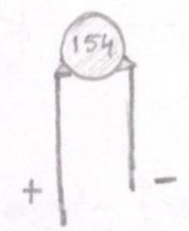

|  |  |
| --- | --- |
| 1. Electrolytic Capacitor: These types of capacitors are mostly used when a very large capacitance values are used.  * Identification of capacitance value and polarity: For electrolytic capacitors, the value of the capacitance is mentioned onto its body. For the polarity determination, we may compare the length of anode lead and cathode lead as in case of mica capacitor. Also, the polarity is marked clearly with a negative sign to indicate the negative terminal and this polarity must be followed.   2021-03-31 (35).png |  |
|  |  |
| 1. Ultra Capacitor: It is another type of electrolytic capacitor that provides capacitance from a few millifarad (mF) to tens of farad in a very small size allowing for much more electrical energy to be stored between the plates.   2021-03-31 (36).png |  |

Diode

A diode is a two terminal electronic device allowing current to move through it in one direction with far greater ease than in the other. Diode has low (ideally zero) resistance in one direction and high (ideally infinite) resistance in the other direction.

Symbol: 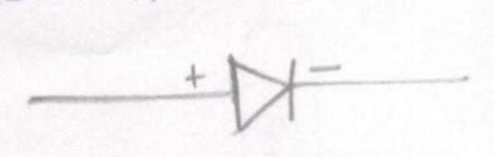

1. Silicon Diode: It is made from silicon and the ‘p-n’ junction properties are utilized for the conduction of current (pentavalent doping agent on n side and trivalent doping agent on p side).

|  |  |
| --- | --- |
| Identification of polarity: Silicon diodes are covered in black plastic cases and the cathode terminal is marked with silver strip.  2021-03-31 (38).png |  |

1. Germanium Diode: Germanium diodes are made from germanium, and in forward biased condition, it conducts current, just like Silicon diode.

|  |  |
| --- | --- |
| Identification of polarity: Germanium diodes are generally glass diodes (kept inside glass cases). The cathode terminal of the glass diode is marked with black band.  2021-03-31 (39).jpg |  |

|  |  |
| --- | --- |
| 1. Zener diode: it is a special type of diode that allows current to flow both in forward and reverse direction. Zener diode is designed to act in reverse bias condition.   Symbol: 2021-03-31 (40).png  Identification of polarity: Cathode terminal of zener diode is marked with black stripe. |  |

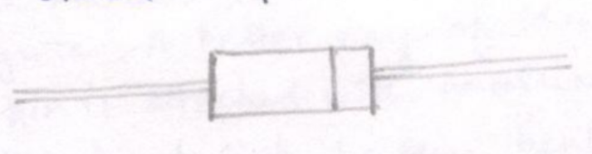

1. Light Emitting Diode: Light emitting diodes (LEDs) are a kind of p-n junction diode working in forward bias condition. The energy released by the recombination of electron-hole pairs produce Photon of monochromatic light.

Symbol: 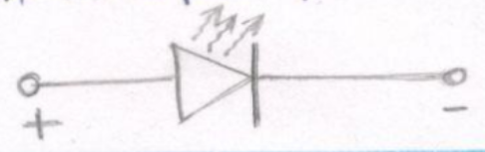

|  |  |
| --- | --- |
| Identification of polarity: all modern LED have their cathode (-ve) terminal identified by either a notch or a flat spot on the body otherwise and easy way for the identification is to compare lead links the cathode lead is shorter than the anode lead |  |

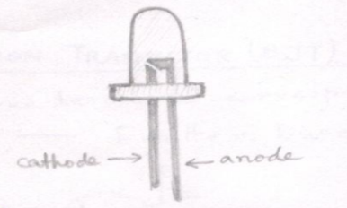

Transistor:

It is a semiconductor device used to amplify or switch electronic signals and electrical power.

Transistors can be of different types:

1. Bipolar Junction Transistor (BJT)
2. Field effect Transistor (FET)
3. Bipolar Junction transistor: It has three terminals corresponding two three layers of semiconductor: Emitter, Base and Collector.

Symbol:   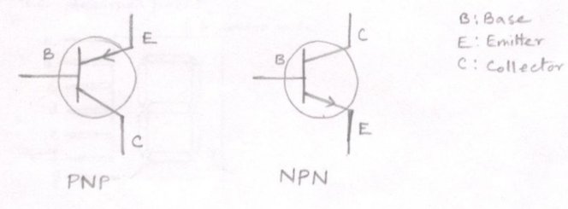

|  |  |
| --- | --- |
|  |  |

|  |  |
| --- | --- |
| Identification of emitter, base and collector: In case of this transistor, the identification of emitter, base and collector are done by observing the position of notch. The emitter is situated closest to the notch. A better way of identification is that, the collector pin is attached with an aluminum cap and shorted to the heat sink because the heat dissipation by collector is maximum. Other two pins are attached with insulated cap. Emitter will be the exactly opposite to the collector.  2021-03-31 (45).png |  |

|  |  |
| --- | --- |
| 1. Power Transistor: It is a kind of BJT, but larger in size than the previous one.   In case of power transistors, there is no necessity for separate identification of the emitter, base and collector, as they are already marked on the body of the transistor.  2021-03-31 (46).png |  |

Seven Segment Display:

|  |  |
| --- | --- |
| It consists of seven light emitting diodes (also called segments) arranged in a rectangular fashion. When illuminated the segments form a part of the numerical digit (both decimal and hexadecimal). The seven segment display is used to display any of the digits from 0 to 9 and two/more such devices together can represent any integer. Sometimes a 8th segment is added to the same package to represent the decimal point. |  |

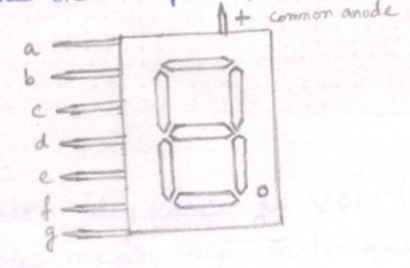

Integrated Circuit (IC)

It is a set of electronic circuits, on one small flat piece or chip of semiconductor material, normally silicon.

Symbol: 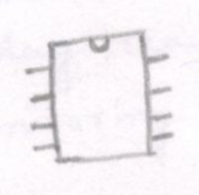

Identification of pins: ICs commonly have 8, 14, 16, 18 or 28 pins. The pins of ICs are numbered from 1, starting from the left side. Keeping the IC with the half moon shaped notch fitting the left hand side, the pin just below the notch is pin 1. Then moving in anticlockwise direction, pins are number 2, 3 and so on. The last pin is at the opposite side of pin 1.

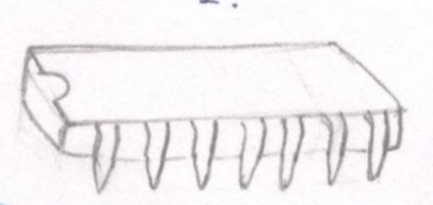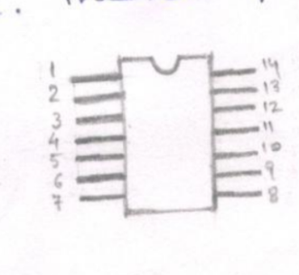

Breadboard: A Breadboard is a solder-less device for temporary prototype for electronics and test circuits design. In a bread board, the holes of the two rows both at the top and bottom are connected horizontally. Remaining holes are connected vertically in each column.

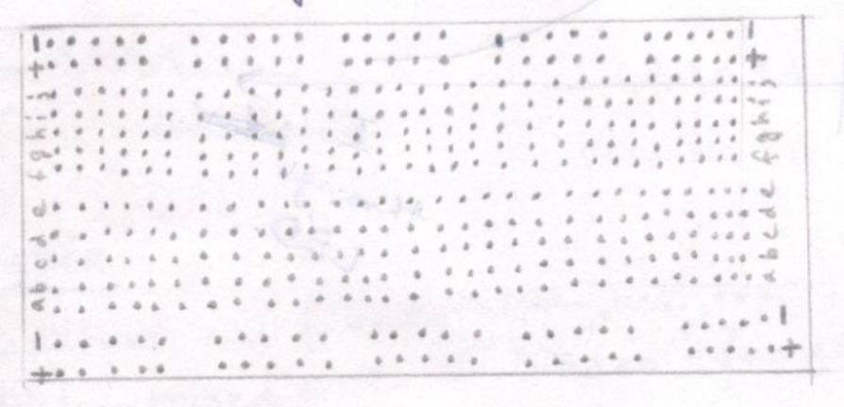

Multi-meter:

A multi-meter, also known as VOM (voltage-ohm- multi-meter) is an electronic measuring instrument that combines several measurement functions is one unit. A typical multi-meter can measure voltage, current and resistance. Mutimeter is of two types:

1. Analog Multi-meter: It uses a microammeter with a moving pointer to display readings. These multi-meters are very useful for monitoring a rapidly varying value.
2. Digital Multi-meter: These multi-meters have a numeric display and are more common due to low cost and high precision.

**JADAVPUR UNIVERSITY**

**Faculty of Engineering & Technology**

**Basic Electronics Laboratory**

Name: ARIYAN BHAUMIK

Class: CSE

Sec: A3

Roll No: 002110501149

Date of Experiment: 11/01/2021

Date of Submission: 06/04/21

Marks Obtained : ………………………

Signature of Examiner : ……………………………

Commenced at : 11:00 am Name of teacher concerned: Nirmoy Modak

**EXPERIMENT NO: 01-B**

TITLE: Verification of Ohm's law using multimeter

THEORY: Ohm's law states that the potential difference applied across the ends of a resistor is directly proportional to the current flowing through it provided the physical conditions such as temperature remains constant.

 APPARATUS REQUIRED:

1. Variable DC power supply

2. Wire wound resistance

3. Connecting wire

4. Multimeter

 CIRCUIT DIAGRAM:

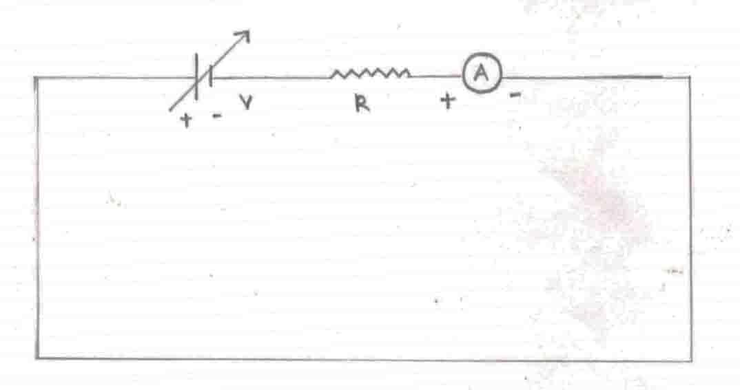

 At constant temperature, V is directly proportional to I;

where V is the applied voltage and I is reading of multimeter;

 Therefore V =IR (R = constant of proportionality called. resistance)

GRAPH:

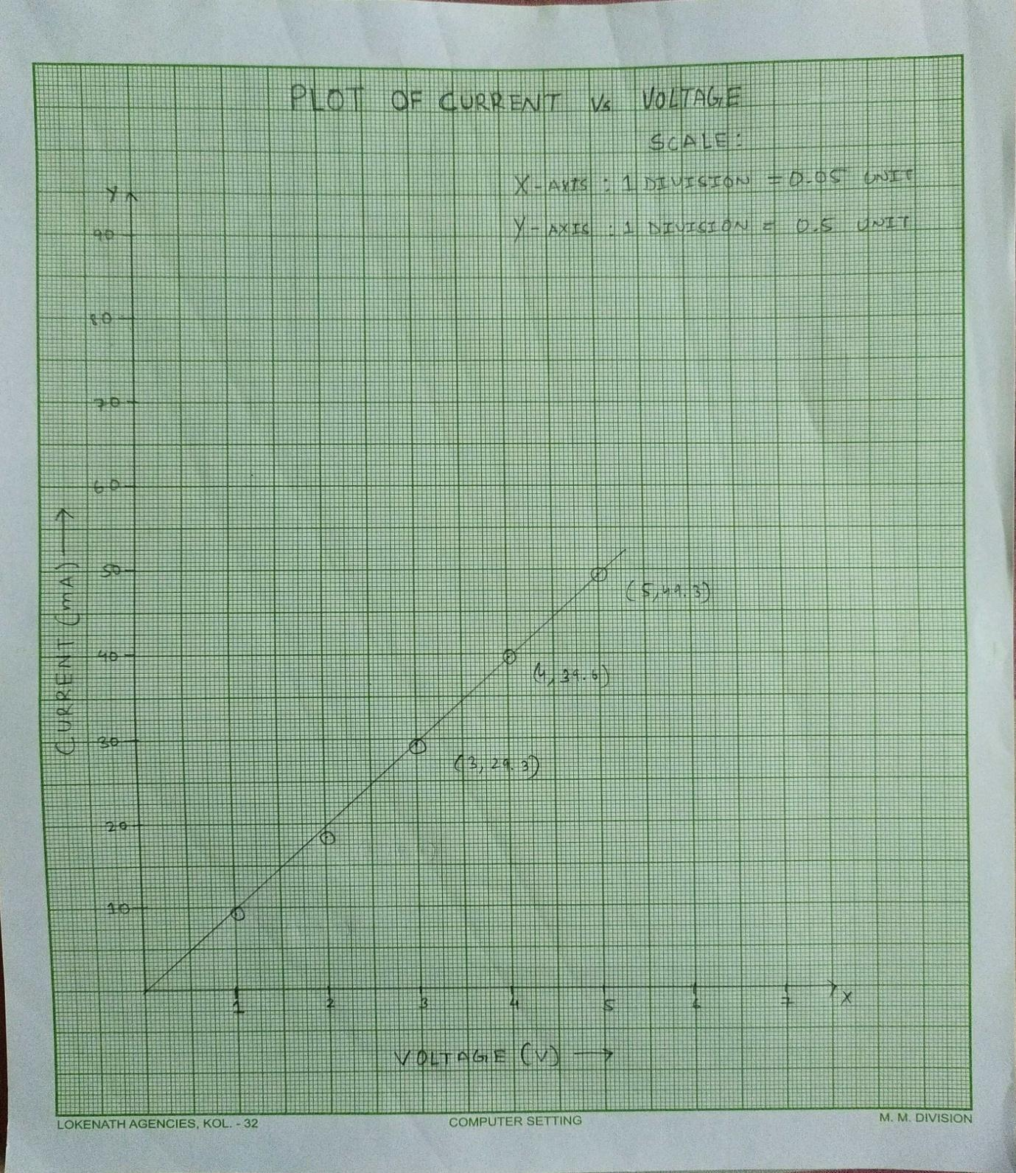

OBSERVATION TABLE:

|  |  |  |
| --- | --- | --- |
| Voltage (in V) | Current (in A) | Resistance (in Ω) |
| 1 | 9.2 | 108 |
| 2 | 18.4 | 108 |
| 3 | 29.3 | 102 |
| 4 | 39.6 | 101 |
| 5 | 49.3 | 101 |

CONCLUSION:  From the graph we can say that voltage varies linearly with current and the graph gives a straight line passing through the origin.

**JADAVPUR UNIVERSITY**

**Faculty of Engineering & Technology**

**Basic Electronics Laboratory**

Name: ARIYAN BHAUMIK

Class: CSE

Sec: A3

Roll No: 002110501149

Date of Experiment: 11/01/2021

Date of Submission: 06/04/21

Marks Obtained : ………………………

Signature of Examiner : ……………………………

Commenced at :11:00 am Name of teacher concerned:Nirmoy modak

**EXPERIMENT NO: 01-C**

TITLE:  Measurement of frequency of Cathode Ray Oscilloscope (CRO) and its handling.

APPARATUS REQUIRED:

1. Cathode Ray Oscilloscope

2. Function Generator

THEORY: CRO is an electronic instrument used to obtain waveforms when the different input signals are given. In the oscilloscope, the CRT produces an accelerated beam of electrons having high velocity and brings to the focal point of the fluorescent screen. The screen produces a visible spot where the electron beam strikes.

There are 2 nobs CH1 and CH2 both of which are used as inputs. CH2 is specially used to trace the lines. Both CH1 and CH2 are calibrated in volts/div.  There are two small nobs calibrated in time/division used to move the wavefront up and down. In this experiment BNC is connected to CH1 and CH2.

OBSERVATION:

 Before calibration:

• Frequency of function generator = 1 kHz

• Time per division = 0.2

•  Time period = 3.4 × 0.2 = 0.68 m sec

• Frequency = 1/0.68 = 1.47 × 10³ Hz

After calibration:

1. Frequency of function generator = 1 kHz

           Time Per division = 0.2

           Voltage per division = 0.1

            Time period =4.9 × 0.2 = 0.98 m sec

            Frequency = 1/0.98 = 1.02 kHz

            Amplitude = 2.4 × 0.1 =0.24 V

2.        Frequency of function generator = 2 kHz

           Time Per division = 0.2

           Voltage per division = 0.1

           Time period = 2.4 × 0.2 = 0.48 m sec

           Frequency = 1/0.48 = 2.08 kHz

          Amplitude = 1.2× 0.1 = 0.12 V

GRAPH:

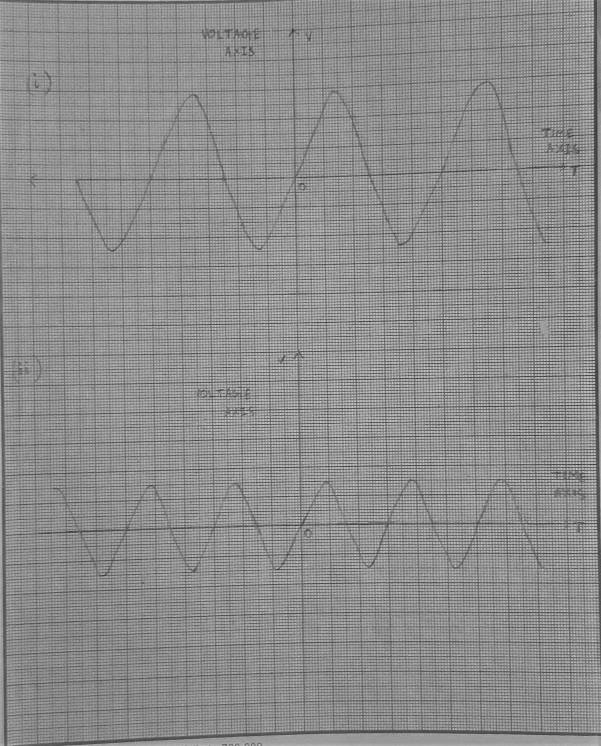

**JADAVPUR UNIVERSITY**

**Faculty of Engineering & Technology**

**Basic Electronics Laboratory**

Name: ARIYAN BHAUMIK

Class: CSE

Sec: A3

Roll No: 002110501149

Date of Experiment: 11/01/2021

Date of Submission: 06/04/21

Marks Obtained : ………………………

Signature of Examiner : ……………………………

Commence At: 11 AM Name of Teacher concerned: Nirmoy Modak

**EXPERIMENT: 2A**

**Title**: *I-V*  Characteristics of Semiconductor Diodes (Si and Ge) under forward and reverse biased conditions.

**Objective:** To become familiar with the operating characteristics of Ge and Si diodes under both forward and reverse biased conditions.

**Working Formula:**

In biased condition of a p-n junction diode the current - voltage relation is given by

I = I0[e^(qV/kbT) – 1]

I = obtained current

V = external voltage

I0 = reverse saturation current

**In Forward Bias**,

Vr = Cut-in Voltage

For V > Vr , e^(qV/kbT) >> 1

Therefore, IF = I0e^(qV/kbT)

**for P-N junction diode:**

* Reverse Static Resistance Rsr = Vr/Ir
* Reverse Dynamic Resistance Rdr = ∆Vr/∆Ir
* Forward Static Resistance Rsf= Vf/If
* Forward Dynamic Resistance Rdf= ∆Vf/∆If

**CIRCUIT DIAGRAM:**

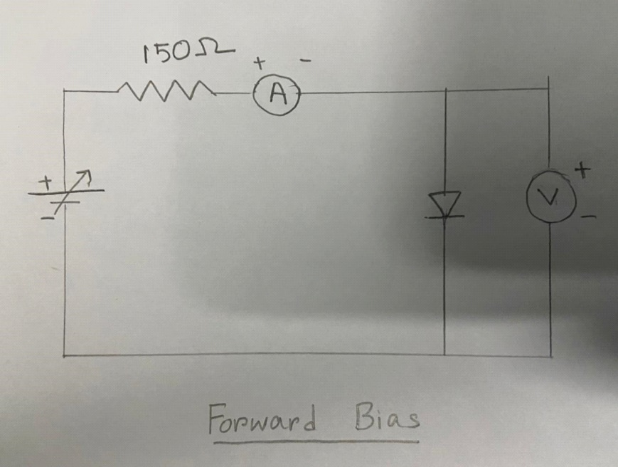

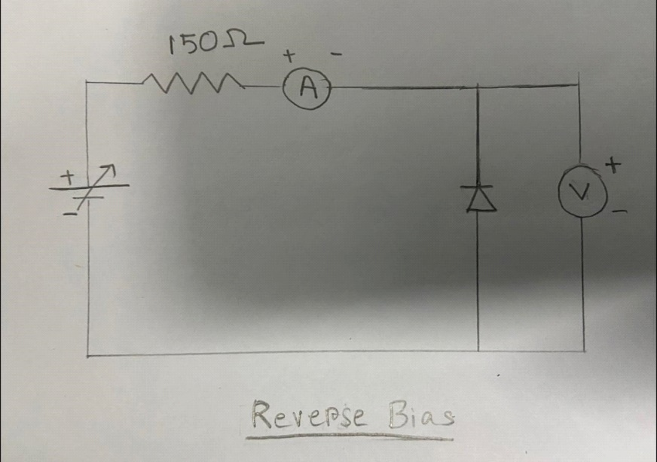

**APPARATUS:**

**Apparatus name Specification Maker's name**

Regulated D.C. 0-35 Volt APLAB

Power supply 0-1A

Digital multimeter - GWINSTEK

**EXPERIMENTAL DATA :**

**Si diode**:

**Forward Bias:**

|  |  |  |
| --- | --- | --- |
| Number of  Observations | Forward Voltage  VF (in volts) | Forward Current  IF (in mA) |
| 1 | 0.100 | 0.000 |
| 2 | 0.200 | 0.000 |
| 3 | 0.300 | 0.000 |
| 4 | 0.440 | 0.060 |
| 5 | 0.510 | 0.280 |
| 6 | 0.530 | 0.480 |
| 7 | 0.560 | 0.800 |
| 8 | 0.580 | 1.270 |
| 9 | 0.620 | 2.250 |
| 10 | 0.630 | 3.300 |
| 11 | 0.650 | 4.600 |
| 12 | 0.660 | 5.800 |
| 13 | 0.670 | 6.300 |
| 14 | 0.680 | 7.780 |
| 15 | 0.690 | 9.400 |
| 16 | 0.710 | 13.180 |
| 17 | 0.720 | 15.500 |
| 18 | 0.740 | 24.000 |
| 19 | 0.750 | 31.200 |

**Reverse Bias:**

|  |  |  |
| --- | --- | --- |
| Number of  Observations | Reverse Voltage  VR(in volts) | Reverse Current  IR(in micro A) |
| 1 | 0.1 | 0.5 |
| 2 | 0.2 | 1.0 |
| 3 | 0.3 | 1.5 |
| 4 | 0.44 | 2.0 |
| 5 | 0.51 | 2.5 |
| 6 | 0.53 | 3.0 |

**Ge diode:**

**Forward Bias:**

|  |  |  |
| --- | --- | --- |
| Number of  Observations | Forward Voltage  VF(in volts) | Forward Current  IF(in mA) |
| 1 | 0.00 | 0.00 |
| 2 | 0.10 | 0.01 |
| 3 | 0.19 | 0.10 |
| 4 | 0.23 | 0.22 |
| 5 | 0.32 | 0.54 |
| 6 | 0.43 | 1.17 |
| 7 | 0.60 | 2.20 |
| 8 | 0.76 | 3.32 |
| 9 | 1.10 | 6.06 |
| 10 | 1.24 | 7.29 |
| 11 | 1.61 | 11.01 |
| 12 | 1.80 | 13.00 |
| 13 | 1.94 | 14.58 |
| 14 | 2.07 | 16.19 |
| 15 | 2.19 | 17.70 |
| 16 | 2.29 | 19.09 |
| 17 | 2.43 | 21.00 |
| 18 | 2.59 | 23.20 |
| 19 | 2.71 | 25.11 |
| 20 | 2.83 | 27.00 |
| 21 | 2.93 | 29.06 |
| 22 | 2.99 | 30.00 |

**Reverse Bias:**

|  |  |  |
| --- | --- | --- |
| Number of  Observations | Reverse Voltage  VR (in volts) | Reverse Current  IR (in micro A) |
| 1 | 0.1 | 0.5 |
| 2 | 1.3 | 0.9 |
| 3 | 4.2 | 1.6 |
| 4 | 7.0 | 2.4 |
| 5 | 8.8 | 2.9 |
| 6 | 11.5 | 3.7 |
| 7 | 14.0 | 4.7 |
| 8 | 17.5 | 6.1 |

**GRAPHS:**

**CALCULATIONS:**

**Forward bias:**

For Si diode,

Forward static resistance (RSF)= VF/IF = 0.72/15 X 103 Ω = 36 Ω

Forward dynamic resistance (RDF)= ΔVF/ΔIF = (0.72-0.71)/(15-13.18) X 103 Ω

=5.49 Ω

For Ge diode,

Forward static resistance (RSF)= VF/IF = 2.00/15 X 103 Ω= 133.3 Ω

Forward dynamic resistance (RDF)= ΔVF/ΔIF = (2.00-1.94)/(15-13)X103 Ω = 30 Ω

**Reverse bias:**

**For Si diode,**

Reverse static resistance (RSR)= VR/IR = 0.44/2 X 106 Ω = 2.2*105 Ω

Reverse dynamic resistance (RDR)= ΔVR/ΔIR = (0.44-0.3)/(2-1.5) X106 Ω

=2.8 X 105 Ω

**For Ge diode,**

Reverse static resistance (RSR)= VR/IR = 0.5/2 X 106 Ω = 2.5 X 105 Ω

Reverse dynamic resistance (RDR)= ΔVR/ΔIR = (0.6-0.5)/(2.2-2) X 106 Ω=5 X105Ω

**CONCLUSIONS:**

From this experiment, studying the I-V characteristics of two different p-n junction diodes, we find that:

* For Si-diode, turn-on voltage is about 0.47 volt and cut-off voltage **is** about 0.6 volt.
* For Ge diode, turn-on voltage is about 0.23 volt and cut-off voltage is about 0.76 volt.

**JADAVPUR UNIVERSITY**

**Faculty of Engineering & Technology**

**Basic Electronics Laboratory**

Name: ARIYAN BHAUMIK

Class: CSE

Sec: A3

Roll No: 002110501149

Date of Experiment: 11/01/2021

Date of Submission: 06/04/21

Marks Obtained : ………………………

Signature of Examiner : ……………………………

Commence At: 11 AM Name of Teacher concerned: Nirmoy Modak

**EXPERIMENT: 2B**

Title: *I-V* Characteristics of Zener Diode

OBJECTIVE: To study the current -voltage characteristics of a reverse biased zener diode and to become familiar with its breakdown characteristics and measure the zener break down voltage.  
  
THEORY:

A Zener diode is constructed for operation in the reverse breakdown region. The relation between I-V is almost linear in this case.

**Vz = Vz0 + Izrz** where **rz** is the dynamic resistance of the zener diode at the operating point. **Vz0** is the voltage at which the straight-line approximation of the I-V characteristics intercects the horizontal axis. After reaching a certain voltage, called the 'Breakdown Voltage, the current increases widely even for a small change in the voltage This happens due to the Avalanche breakdown and the Zener effect of the Zener diode. However, there is no appreciable change in voltage After the zener potential **Vz**, current increases exponentially.

CIRCUIT DIAGRAM**:**

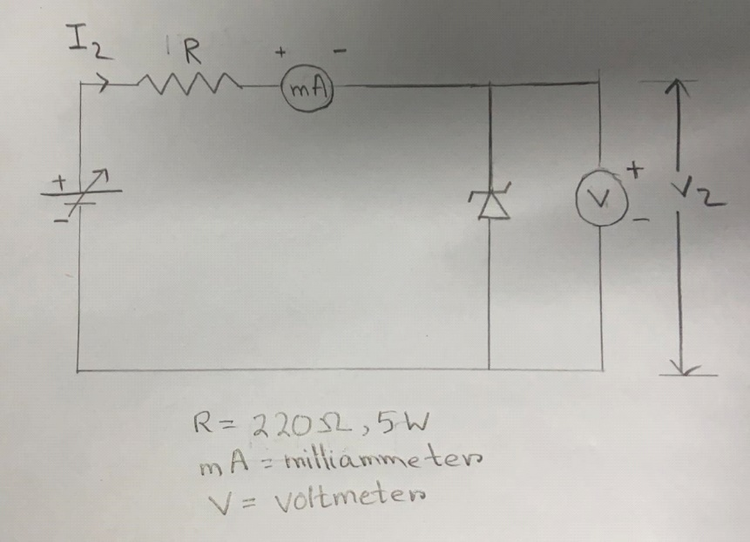

**APPARATUS USED:**

**Apparatus Used Specification Maker’s Name**

Regulated DC (0-30) Volt ELNOVA

power supply (0-2) amp

Analog Multimeter SANWA INDIA

Digital Multimeter GWINSTEK

**WORKING FORMULA:**

In case of the diode the current equation is given by,

I = I0[e^(qV/kbT) – 1]

Where I0 = Reverse saturation current

V = External voltage applied

kBT = constant

In case of reverse biased zener diode,

Applied voltage V = -Vr

Then I **≈** -I0

Reverse static resistance **Rzs** is given by,

**Rzs = Vr/Ir**

Reverse dynamic resistance **Rzd** is given by ,

**Rzd = ∆Vr/∆Ir**

EXPERIMENTAL DATA**:**

**DIODE 1**

|  |  |  |
| --- | --- | --- |
| **Obs.**  **No.** | **Vz(volt)** | **Iz(mA)** |
| 1 | 0 | 0 |
| 2 | 8.0 | 0.008 |
| 3 | 9.0 | 0.010 |
| 4 | 10.0 | 0.011 |
| 5 | 10.5 | 0.011 |
| 6 | 11.0 | 0.012 |
| 7 | 11.3 | 0.062 |
| 8 | 11.7 | 0.090 |
| 9 | 11.9 | 2.150 |
| 10 | 12.0 | 2.710 |
| 11 | 12.0 | 3.760 |
| 12 | 12.0 | 4.960 |
| 13 | 12.0 | 14.020 |

**DIODE 2**

|  |  |  |
| --- | --- | --- |
| **Obs.**  **No.** | **Vz(volt)** | **Iz(mA)** |
| 1 | 0 | 0 |
| 2 | 3.0 | 0.003 |
| 3 | 4.0 | 0.004 |
| 4 | 5.0 | 0.006 |
| 5 | 5.5 | 0.020 |
| 6 | 5.6 | 0.030 |
| 7 | 6.0 | 0.056 |
| 8 | 6.0 | 0.190 |
| 9 | 6.0 | 0.622 |
| 10 | 6.0 | 1.150 |
| 11 | 6.0 | 2.340 |
| 12 | 6.0 | 3.380 |
| 13 | 6.0 | 4.840 |

GRAPHS:

**CALCULATION :**

For DIODE 1 , reverse breakdown voltage = 11.9 V

For DIODE 2 , reverse breakdown voltage = 6.0 V

***For Diode 1 ,***

For Iz = 10 mA , Vz = 12.0 V

Reverse static resistance **Rzs = Vr/Ir** = 12.0/10X10-3 = 1.2 k Ω

Reverse dynamic resistance **Rzd = ∆Vr/∆Ir =** (12.0-12.0)V/(10-4.976)*10^-3 A

= 0 Ω

***For Diode 2 ,***

For Iz = 10 mA , Vz = 6.0 V

Reverse static resistance **Rzs = Vr/Ir** = 6.0/10X10-3 = 0.6 k Ω

Reverse dynamic resistance **Rzd = ∆Vr/∆Ir =** (6.0-6.0)/(10-5.02)

= 0 Ω

**CONCLUSION:**

The Reverse Breakdown Voltage for Zener diode 1 = 11.9 Volt

The Reverse Breakdown Voltage for Zener diode 2 = 6 volt.

Hence, reverse breakdown voltage is not same for the two cases as we know reverse breakdown voltage of Zener diode is dependent on several factors like semiconductor material, doping level etc.

**JADAVPUR UNIVERSITY**

**Faculty of Engineering & Technology**

**Basic Electronics Laboratory**

Name: ARIYAN BHAUMIK

Class: CSE

Sec: A3

Roll No: 002110501149

Date of Experiment: 11/01/2021

Date of Submission: 06/04/21

Marks Obtained : ………………………

Signature of Examiner : ……………………………

Commence At: 11 AM Name of Teacher concerned: Nirmoy Modak

**EXPERIMENT NO: 03**

Objective**:** To study the ripple characteristics of a full wave rectifier with capacitor filter against varying load current.

Circuit Diagram**:**

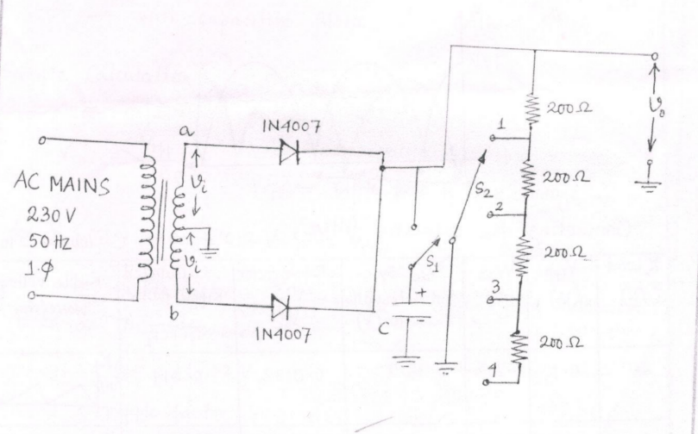

Apparatus list:

|  |  |  |  |  |  |
| --- | --- | --- | --- | --- | --- |
| Sl. no. | Apparatus name | Qty | Range/Rating | Maker’s name | Maker’s number |
| 1 | Multimeter (used as voltmeter) | 1 | 0-20 V | CIE | 110419681 |
| 2 | Capacitor | 1 | 1000 𝜇F | - | - |
| 3 | Resistor | 4 | 200 𝛺 each | - | - |
| 4 | Diodes | 2 | 1N4007 | - | - |
| 5 | Oscilloscope | 1 |  |  |  |

Observation:

|  |  |  |  |  |  |  |
| --- | --- | --- | --- | --- | --- | --- |
| Sl. no. | RL (𝛺) | Vrpp(Volts) | Vrms=Vrpp/2√3 | Vdc by voltmeter with capacitor | Ripple factor=Vrms/Vdc | Calculated Ripple factor |
| 1 | 200 | 0.64 | 0.1848 | 15.85 | 0.0116 | 0.0144 |
| 2 | 400 | 0.32 | 0.0924 | 16.20 | 0.0057 | 0.0072 |
| 3 | 600 | 0.22 | 0.0635 | 16.32 | 0-.0039 | 0.0048 |
| 4 | 800 | 0.17 | 0.0491 | 16.52 | 0.0029 | 0.0036 |

Vac=36 V

Vac=16 V

**Time Periods:**

Non rectified sine wave: 20 ms

Rectified wave:10 ms

Filtered wave:10 ms

GRAPHS:

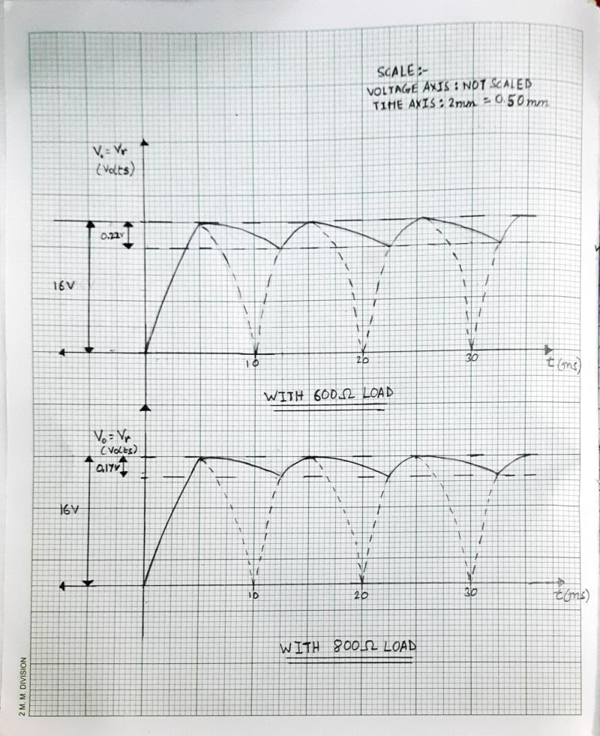

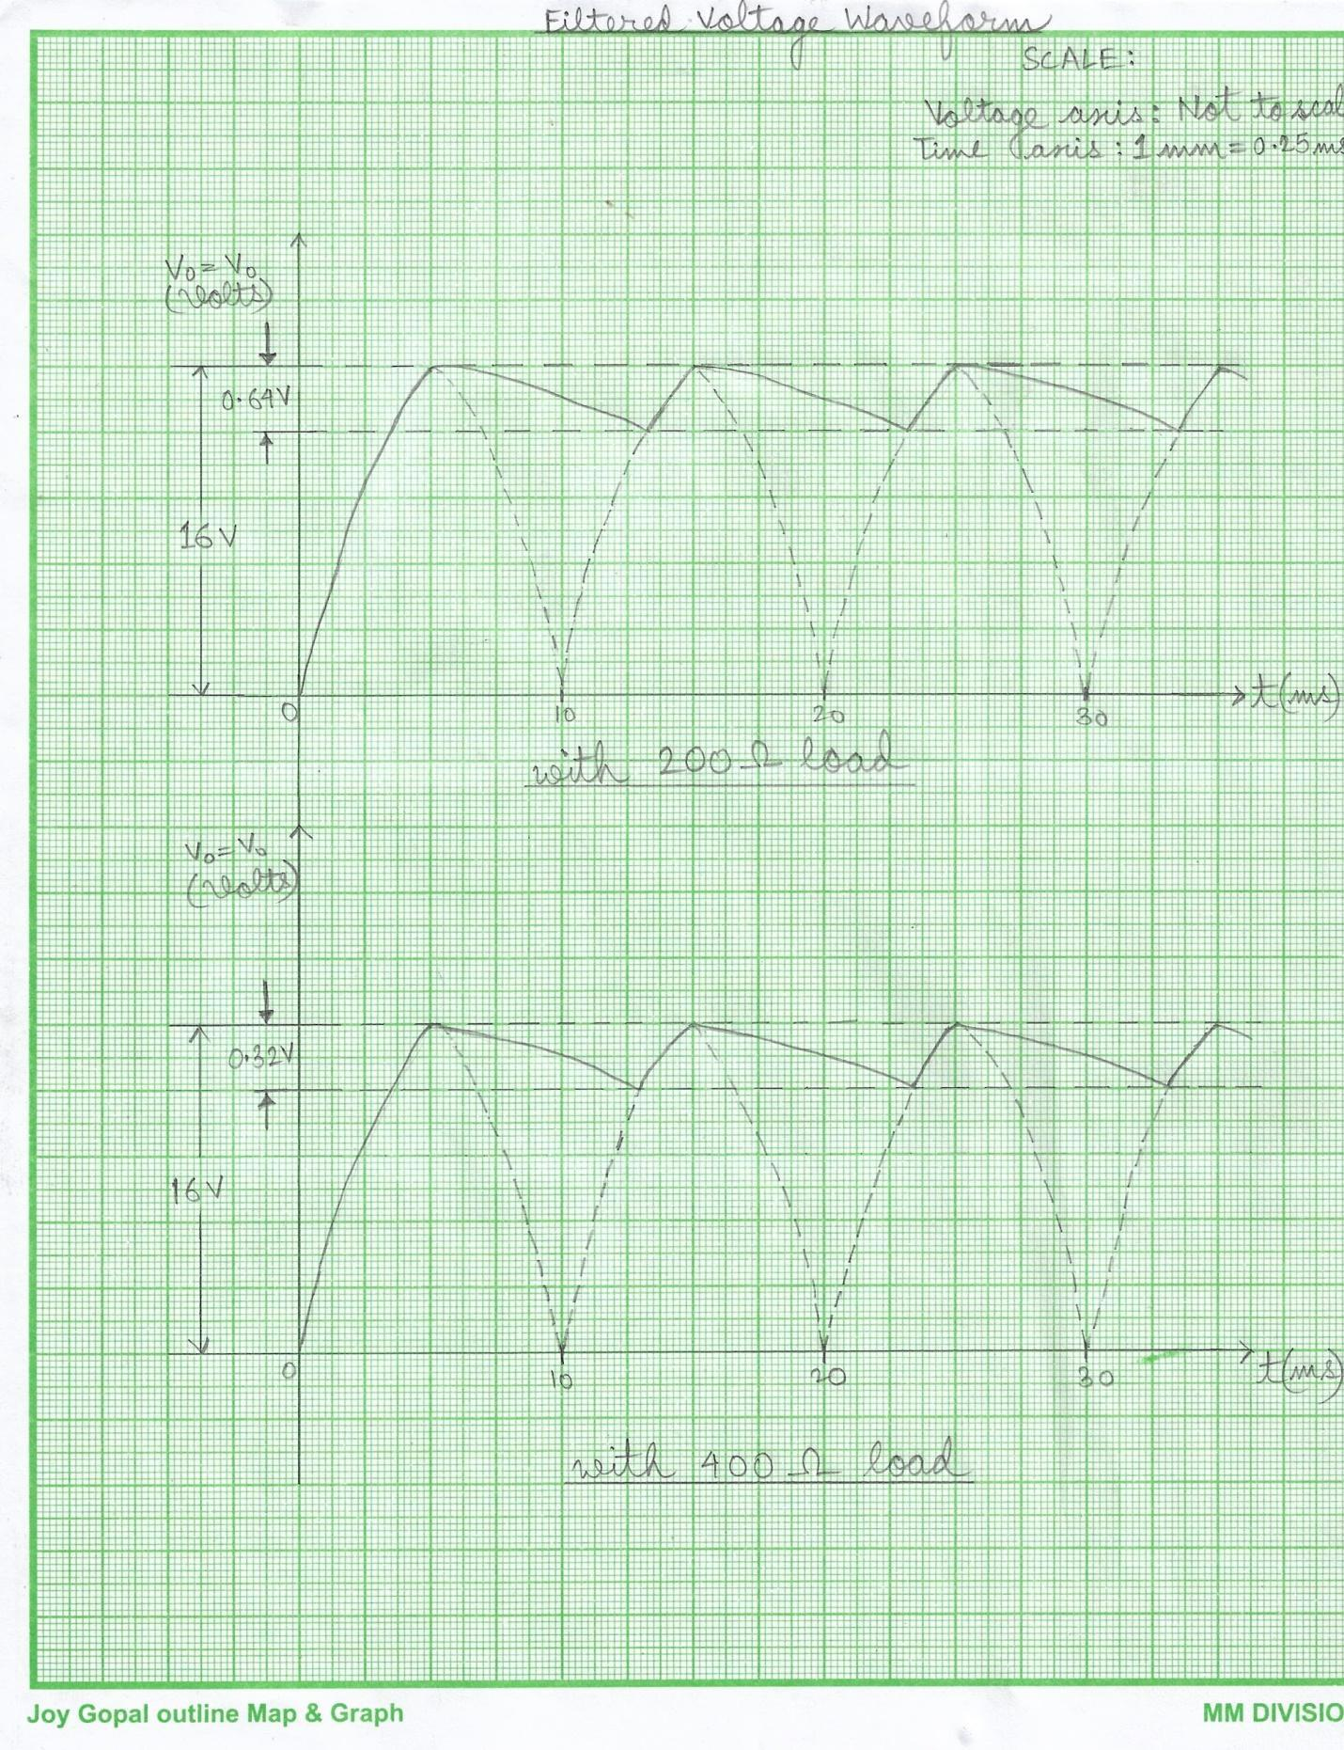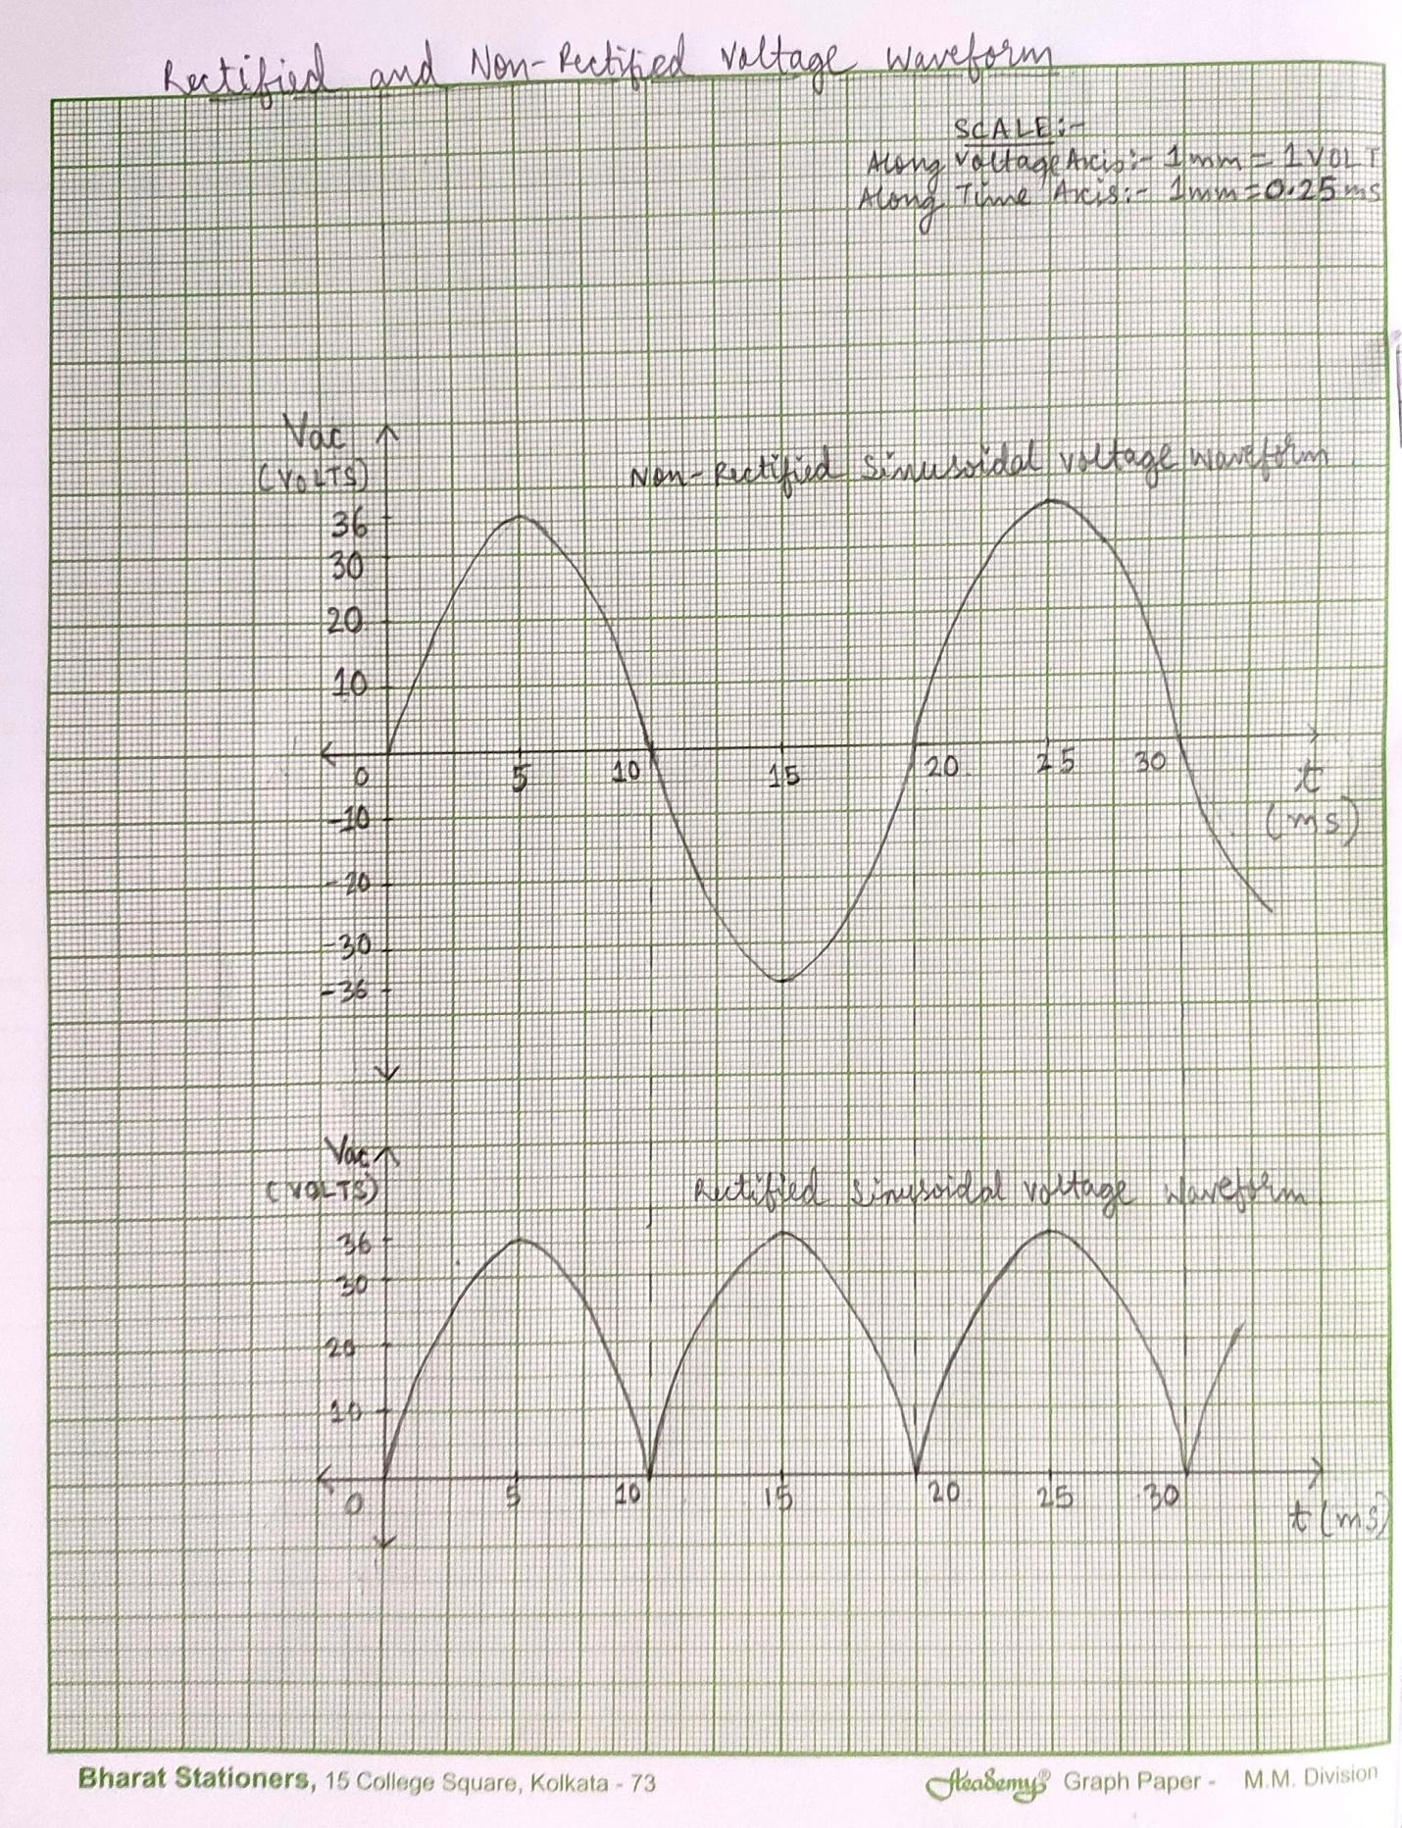

**JADAVPUR UNIVERSITY**

**Faculty of Engineering & Technology**

**Basic Electronics Laboratory**

Name: ARIYAN BHAUMIK

Class: CSE

Sec: A3

Roll No: 002110501149

Date of Experiment: 11/01/2021

Date of Submission: 06/04/21

Marks Obtained : ………………………

Signature of Examiner : ……………………………

Commence At: 11 AM Name of Teacher concerned: Nirmoy Modak

**EXPERIMENT NO: 04**

Objective**:**  To study the function of OPAMP as

1. Inverting amplifier
2. Non-inverting amplifier
3. Buffer

Apparatus required:

1. Bread board
2. M741 IC
3. Jump wires
4. Multimeter as Voltmeter
5. Sine generator
6. DC voltage supply
7. Inverting amplifier circuit
8. Non-inverting amplifier circuit
9. Buffer circuit

Theory: An inverting amplifier using OPAMP gives an output wavefront phase opposite to the input wavefront. The gain for such circuits(AV) is

AV = Rf/Ri

where Rf = Feedback resistor, Ri = Input resistance

A buffer circuit gives the output as sum of several input . For two input voltages V1 and V2 and input resistance as R1 and R2.

Vo = -[( Rf/R1)V1 + ( Rf/R2)V2]

Vo = Output voltage, Rf = Feedback resistor

Circuit diagram**:**

1. 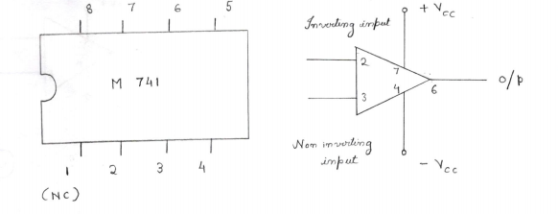**Functional diagram:**
2. **Inverting amplifier:**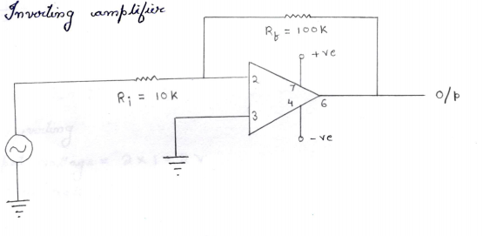
3. **Non inverting amplifier:**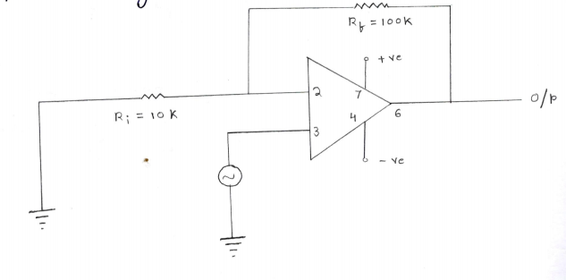

Observation**:**

1. Inverting amplifier

Input voltage = 2 X 1 = 2 V

Output voltage = 3.6 X 5 = 18 V

Experimental AV = 18 / 2 = 9

Calculated AV = Rf/Ri  = 100 kΩ / 10 kΩ = 10

1. Non-inverting amplifier

Input voltage = 0.2 X 1 = 0.2 V

Output voltage = 2.2 V

Experimental AV = 2.2 / 0.2 = 11

Calculated Ac =1 + Rf/Ri = 1 + 100 kΩ / 10 kΩ = 11

1. Buffer

|  |  |  |  |  |
| --- | --- | --- | --- | --- |
| Serial  Number | V1     (V) | V2     (V) | V(Practical)        (V) | V(Calculated)          (V) |
| 1 | 0.1 | 0.1 | -3.04 | -3.25 |
| 2 | 0.1 | 0.2 | -4.70 | -4.62 |
| 3 | 0.2 | 0.3 | -7.90 | -7.82 |
| 4 | 0.4 | 0.2 | -9.90 | -9.96 |

1. Summing amplifier

Voltage (V1) = 0.22 V

               (V2) = 0.31 V

Observed value of Output Voltage = 8.47 V

  Theoretical Value = - [( Rf/R1)V1 + ( Rf/R2)V2]

            = - [ (100 / 5.6 ) X 0.22 + (100/8.8) X 0.31]= - 8.485 V

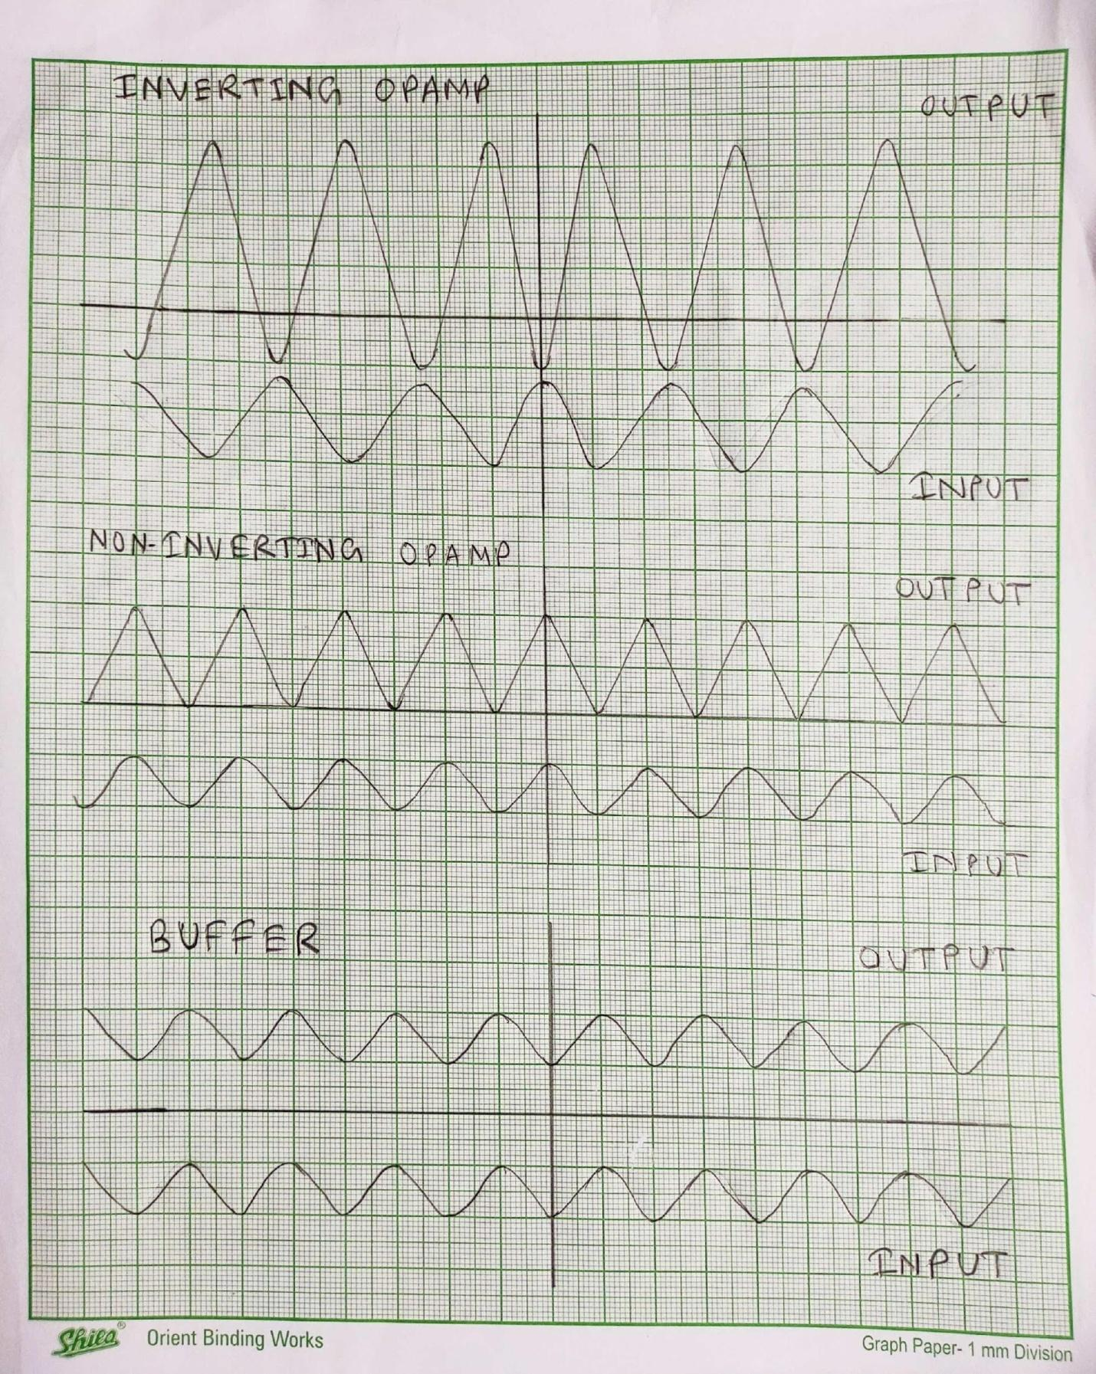

**JADAVPUR UNIVERSITY**

**Faculty of Engineering & Technology**

**Basic Electronics Laboratory**

Name: ARIYAN BHAUMIK

Class: CSE

Sec: A3

Roll No: 002110501149

Date of Experiment: 11/01/2021

Date of Submission: 06/04/21

Marks Obtained : ………………………

Signature of Examiner : ……………………………

Commence At: 11 AM Name of Teacher concerned: Nirmoy Modak

**EXPERIMENT NO: 05**

**Objective:**  To study Truth Table of basic gates and NAND gate as universal gate.

**Apparatus required:**

1. IC - 7400
2. Regulated DC power supply
3. Bread board
4. LED
5. Resistor

**IC – 7400 :** The series of transistor logic IC are now very popular and are quickly replacing diode transistor logic. It has 14 pairs and 4 inbuilt NAND gates.

Input pairs : 1 & 2, 4 & 5, 9 & 10, 12 & 13

Output pairs : 3, 6, 8, 11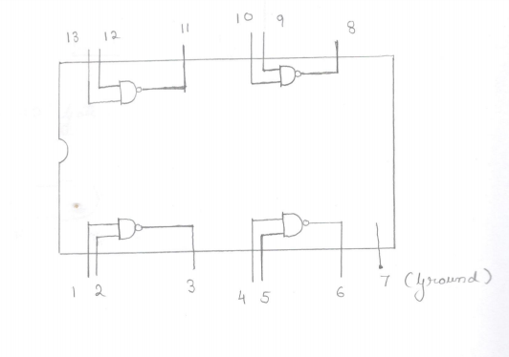

**Universal gate:** NAND and NOR gates are called universal gates as they can be used to construct any Boolean function without using any other gate. They are economical to fabricate.

**AND gate:**

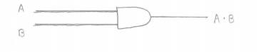

Truth Table:

|  |  |  |  |
| --- | --- | --- | --- |
| Serial  Number | A | B | A . B |
| 1 | 0 | 0 | 0 |
| 2 | 0 | 1 | 0 |
| 3 | 1 | 0 | 0 |
| 4 | 1 | 1 | 1 |

Using NAND gate:

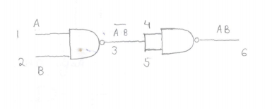

|  |  |  |  |  |
| --- | --- | --- | --- | --- |
| Serial  Number | A | B | (A.B)-1 | A.B |
| 1 | 0 | 0 | 1 | 0 |
| 2 | 0 | 1 | 1 | 0 |
| 3 | 1 | 0 | 1 | 0 |
| 4 | 1 | 1 | 0 | 1 |

**OR gate:**

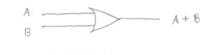

Truth Table:

|  |  |  |  |
| --- | --- | --- | --- |
| Serial number | A | B | A+B |
| 1 | 0 | 0 | 0 |
| 2 | 0 | 1 | 1 |
| 3 | 1 | 0 | 1 |
| 4 | 1 | 1 | 1 |

Using NAND gate:

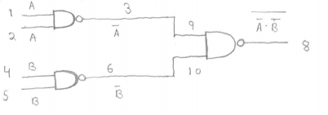

|  |  |  |  |  |  |
| --- | --- | --- | --- | --- | --- |
| Serial  Number | A | B | (A)-1 | (B)-1 | ((A)-1(B)-1)-1 |
| 1 | 0 | 0 | 1 | 1 | 0 |
| 2 | 0 | 1 | 1 | 0 | 1 |
| 3 | 1 | 0 | 0 | 1 | 1 |
| 4 | 1 | 1 | 0 | 0 | 1 |

**NOT gate :**

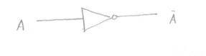

Truth Table:

|  |  |  |
| --- | --- | --- |
| Serial  Number | A | (A)-1 |
| 1 | 0 | 1 |
| 2 | 1 | 0 |

**Using NAND Gate:**

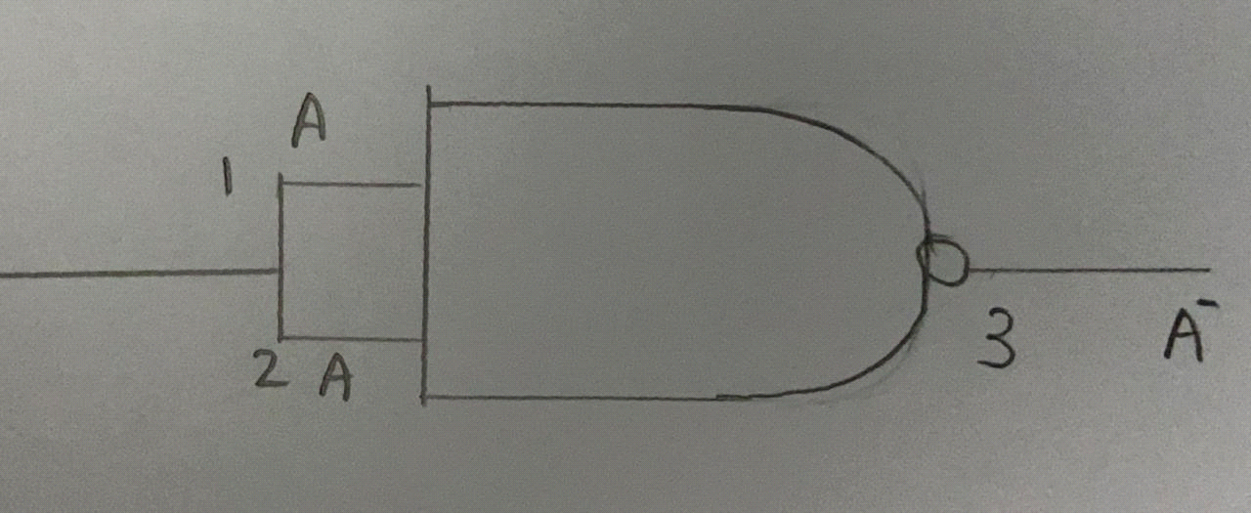

---------- THE END ----------